Water Wand for Organic Pest Control
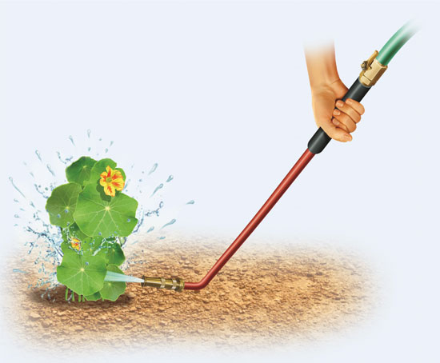
Use a Watering Wand for Organic Pest Control
Blast aphids, spider mites and powdery mildew out of your garden with this common gardening tool.

You can create a custom watering wand that’s perfect for blasting unwanted bugs and mildew spores off the plants in your organic garden. Illustration by Peter Bull
A modified watering wand is the best organic pest control that I’ve found! It’s inexpensive, safe, easy to use, and effective for the prevention and removal of aphids, spider mites and powdery mildew.
To make this tool, you’ll need a watering wand and an adjustable brass hose nozzle. Both are available at any hardware store or gardening center; the watering wand costs between $10 and $30 and the nozzle is about $5. Remove the shower nozzle that comes attached to the wand and replace it with the hose nozzle. If your watering wand doesn’t come with a shut-off valve, you should invest in one.
Turn the water on full blast and adjust the new nozzle to create a high-pressure spray. You’re dislodging the pests, not refreshing them with a shower! The angled head of the watering wand will allow you to direct the spray upward to remove pests on the underside of the foliage. Spray from below and above to remove all pests. Do this several times a week during heavy pest season.
Be proactive about powdery mildew and wash off spores before you even see mildew. After you see mildew, you can wash it off, but you’ll need to do so every day, and removal will be slow.
Source: Cindy Jepsen (http://www.motherearthnews.com/organic-gardening/pest-control/watering-wand-zm0z15amzkin.aspx)

